Peruvian Chicken (Pollo a la Brasa)
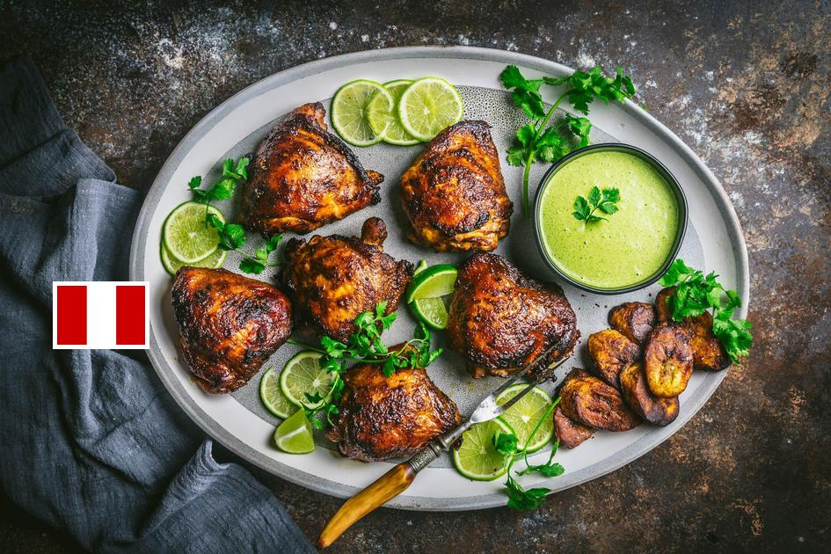
DESCRIPTION:
A simple recipe for Peruvian Chicken with spicy Peruvian Green Sauce is bursting with flavor and can be made with either chicken or portobellos (a tasty vegetarian option) or both for mixed households. Served with Spicy Cilantro Sauce, Avocado Cucumber & Tomato Salad and optional rice, these can be made into individual Bowls, or served separately.

INGREDIENTS:
1 1/2 –2 pounds chicken (thigh or breast, boneless, skinless- see notes) Or substitute portobellos!
Marinade:
4 garlic cloves- finely minced
2 tablespoons olive oil
2 tablespoons lime juice
2 teaspoons honey, agave or sugar
1 tablespoon cumin
2 teaspoons paprika or smoked paprika
1 teaspoon coriander
1 teaspoon dried oregano ( or 1 tablespoon fresh) or sub thyme or marjoram
1 1/2 teaspoon kosher salt
1 teaspoon soy sauce ( optional)
Peruvian Green Sauce (Aji Verde) :
1/2 cup sour cream or mayo (see notes for vegan option)
1/2 jalapeño (use less for less spicy)
1 garlic clove
1 cup chopped cilantro- thin stems ok.
1/4 teaspoon kosher salt
a squeeze of lime ( 1 tablespoon, save other half for salad)
Avocado Cucumber Tomato Salad
2 cups diced or sliced English or Turkish cucumber
1–2 perfectly ripe avocados, diced
1 cup cherry tomatoes ( yellow and red are nice )
cilantro leaves for garnishing
olive oil for drizzling
generous, 5 finger pinch kosher salt
squeeze of lime
Optional Bowl Additions- cooked Cilantro Lime Rice or Mexican Pinto Beans…. or both.
Cook Mode Prevent your screen from going dark

INSTRUCTIONS:
Preheat grill to medium-high.
If making rice, start this now on the stove.
Make the marinade in a small bowl. Using a garlic press, finely mince the garlic and place it in the bowl. Add oil, lime juice, honey, cumin, paprika, coriander, oregano and salt and optional soy sauce. Stir. Toss it with the chicken in a bowl, coating all sides well, and/ or brush it onto the portobellos. Marinate while the grill heats up or overnight for more flavor. (The portobellos will soak up the marinade so if marinating overnight go lightly, reapply before grilling.)
Make Peruvian Green Sauce by placing all the ingredients in a blender and blending until relatively smooth, scraping down the sides if necessary.
When the grill is hot, grill the chicken and/ or portobellos, searing both sides well ( using a metal spatula to flip) then turn the heat down or move to a cooler side of the grill to allow the chicken to cook through. Portobellos will cook faster, so plate and cover with foil to keep warm.
Make the salad by placing the diced cucumber in a wide shallow bowl. Add avocado, spacing it out evenly. Add a few cherry tomato halves. Sprinkle generously with salt and pepper and drizzle lightly with olive oil. Squeeze with lime juice. Garnish with cilantro leaves.
Serve with the Cilantro Lime Rice. If making bowls, place ¾ cup rice on the bottom of the bowl, add sliced chicken or portobellos to one side, avocado salad on the other side and drizzle with the cilantro sauce. Enjoy!

NUTRITION:
Serving Size: -with chicken breast, one avocado and the green sauce
Calories: 241Sugar: 2.1 g
Sodium: 146.5 mg
Fat: 17.7 g
Saturated Fat: 4.7 g
Carbohydrates: 8.5 g
Fiber: 3.1 g
Protein: 14 g
Cholesterol: 48.4 mg

